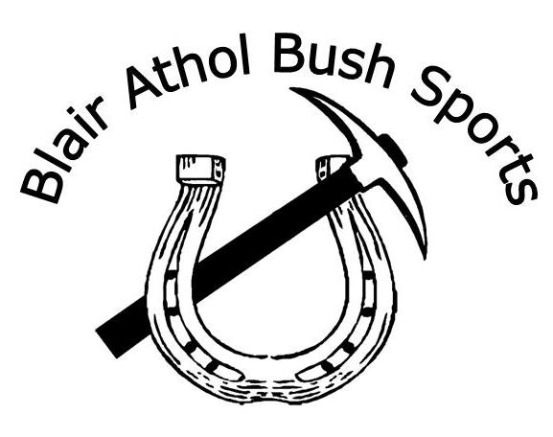
Blair Athol Bush Sports
4th & 5th May 2019
Campdraft is affiliated with Australian Campdraft Association.

SATURDAY 4th May 6:30AM START
$1,500 Maiden/Maiden4Maiden Draft
Maiden for Maiden to be run in conjunction with Maiden Draft and separate final.
Maiden 4 Maiden will break status of the highest scoring horse and rider.
One round and final.
Nomination - $30
Maiden 4 Maiden Nomination - $10

$3000 Open Draft
Unrestricted. One round and final.
Nomination - $50

$500 Futurity Draft
One round.
Horses 4 years and younger, horses must be verified on Campdraft Central
Horses competing in the Futurity must not have started in an open age event.
Nomination - $25

Maiden 4 Maiden Final
Maiden Final

Open Final

SUNDAY 5th May 6:30AM START
$300 Juvenile Draft
Competitors must be aged between 13 and under 17 years.
Restricted to two (2) horses.
Nomination - $15

$2,000 Novice Draft
One round & final.
Nomination - $40

Mini Draft
Competitors must be aged under 8 years.
Horses in this draft must not compete in any other draft (unaffiliated).
Restricted to one (1) horse.
Nominations - $5

Junior Horsemanship Event
Competitors must be aged between 8 and under 13 years.
Horses in this draft must not compete in any other draft (unaffiliated).
Restricted to one (1) horse.
Nomination - $10

Novice Final

NOMINATIONS VIA CAMPDRAFT CENTRAL

www.campdraftcentral.com.au

Nominations open
Tuesday, 16th April 2019 at Midday
Nominations Close –
Wednesday, 17th April 2019 at Midday

The Campdraft Central 24 hour System will be used. Restrictions will be imposed if necessary and will be at the Committee’s discretion only. Competitors will be invoiced after nominations have been finalised Wednesday evening.
All Nominations are to be paid in full by 25th April 2019.

Cheques to be sent to:
BA Bush Sports
PO Box 153
CLERMONT QLD 4721
Direct Deposit
Account Name: Blair Athol Bush Sports
BSB: 014550
Account Number: 221925816

Scratching’s close
5pm, Friday, 26th April 2019.
All scratching’s before this will be fully refunded. Scratching’s after this until 5pm 30th April will incur a $15 per nomination fee. All scratching’s after this will not be refunded unless extenuating circumstances.
NO Nominations will be taken on the day.

Prize money will be paid as per ACA Guidelines (R.9)
Housekeeping
- Catering, Camping, Showers & Toilets on the Grounds. No powered sites.
- Catering Provided by Penny’s Plaza Coffee Shop.
- Catering available from Friday evening to Sunday afternoon.
- Bar operating Friday through until Sunday evening.
- Entertainment Friday and Saturday nights.

Conditions
- All competitors ride at their own risk.
- Judges decision is final.
- The committee reserves the right to alter or omit any event and to include others as necessary.
- The committee reserves the right to refuse entry or nomination.
- The committee insists rough riders use own gear.
- Nominations will not be refunded except to inured riders.
- No persons under the influence of alcohol will be allowed in the ring.
- Riders under the age of 18must wear helmets whilst mounted on a horse at all ACA affiliated events. Helmets must comply with current safety standards and must be securely fastened under the chin at all times.
- The draw will be strictly adhered to.
- Nominations are to be paid before entering events.
- The BA Bush Sports committee does not assume liability for accidents or injury to competitors, for their stock or loss/damage to their property and each competitor by act of entry or participation waives all claims for injury, loss or damage that they, their helpers, their stock, or their property may sustain.
- Any competitor who wishes to lodge a complaint at an affiliated campdraft must lodge the complain in writing with the secretary of the host committee within one (1) hour of the incident taking place. A fee of $20 must be lodged with the complaint. If the complaint is dismissed by the Committee, the $20 if forfeited.
- From 1st April, 2006 it is compulsory at any ACA affiliated campdraft in Australia for all campdraft competitors to be a Full Member.
- The status of a horse winning a campdraft will be determined by the highest class or horse that competes with the expception of Juniors, Juveniles, Ladies, Old Buffers, Associates and Encouragement Campdrafs. The winner attains the status of the highest class of horse participating (e.g. if one Open horse competes then it is classed as an Open draft.)

For more information please contact Ashleigh Fairbrother on 0448100685

